2 H₂O + 4 MnO₄– + 3 ClO₂– −−> 4 MnO₂ + 3 ClO₄– + 4 OH–
Which species acts as an oxidizing agent in the reaction represented above?e
(A) H₂O (B) ClO₄– (C) ClO₂–
(D) MnO₂ (E) MnO₄–

Zn(s) + Cu²⁺ → Zn²⁺ + Cu(s)
An electrolytic cell based on the reaction represented above was constructed from zinc and copper half–cells. The observed voltage was found to be 1.00 volt instead of the standard cell potential, Eº, of 1.10 volts. Which of the following could correctly account for this observation?c
(A) The copper electrode was larger than the zinc electrode.
(B) The Zn²⁺ electrolyte was Zn(NO₃)₂, while the Cu²⁺ electrolyte was CuSO₄.
(C) The Zn²⁺ solution was more concentrated than the Cu²⁺ solution.
(D) The solutions in the half–cells had different volumes.
(E) The salt bridge contained KCl as the electrolyte.

What is the maximum mass of copper that could be plated out by electrolyzing aqueous CuCl₂ for 16.0 hours at a constant current of 3.00 amperes? (1 faraday = 96,500 coulombs) b
(A) 28 grams (B) 57 grams (C) 64 grams
(D) 114 grams (E) 128 grams

A direct–current power supply of low voltage (less than 10 volts) has lost the markings that indicate which output terminal is positive and which is negative. A chemist suggests that the power supply terminals be connected to a pair of platinum electrodes that dip into 0.1–molar KI solution. Which of the following correctly identifies the polarities of the power supply terminals? B
(A) A gas will be evolved only at the positive electrode.
(B) A gas will be evolved only at the negative electrode.
(C) A brown color will appear in the solution near the negative electrode.
(D) A metal will be deposited on the positive electrode.
(E) None of the methods above will identify the polarities of the power supply terminals.

6 I– + 2 MnO₄– + 4 H₂O(l) ∅ 3 I₂(s) + 2 MnO₂(s) + OH–
Which of the following statements regarding the reaction represented by the equation above is correct?e
a. Iodide ion is oxidized by hydroxide ion.
b. MnO₄– is oxidized by iodide ion.
c. The oxidation number of manganese changes from +7 to +2.
d. The oxidation number of manganese remains the same.
e. The oxidation number of iodine changes from –1 to 0.

Fe²⁺ + 2e– −> Fe(s) E_ = –0.44 volt
Ni²⁺ + 2e– −> Ni(s) E_ = –0.23 volt
The standard reduction potentials for two half reactions are given above. The Nernst equation for a galvanic cell at 25_C in which Fe(s) reduces Ni²⁺ is the following.
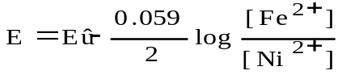
What is the equilibrium constant for the reaction below?d
Fe(s) + Ni²⁺ ∅ Fe²⁺ + Ni(s)

a. 1.9∞10^{–23} c. 3.6∞10⁺³ e. 5.2∞10⁺²²
b. 7.6∞10^{–8} d. 1.3∞10⁺⁷

If a copper sample containing some zinc impurity is to be purified by electrolysis, the anode and the cathode must be which of the following?d
Anode Cathode
a. Pure copper Pure zinc
b. Pure zinc Pure copper
c. Pure copper Impure copper sample
d. Impure copper sample Pure copper
e. Impure copper sample Pure zinc

Question 14–17
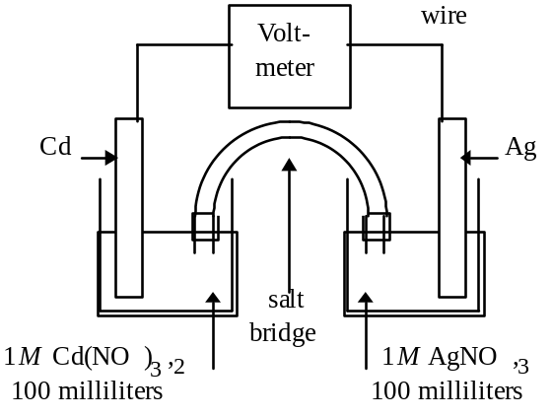
The spontaneous reaction that occurs when the cell above operates is 2 Ag⁺ + Cd(s) −> 2 Ag(s) + Cd²⁺
(A) Voltage increases.
(B) Voltage decreases.
(C) Voltage becomes zero and remains at zero
(D) No change in voltage occurs
(E) Direction of voltage change cannot be predicted without additional information
Which of the above occurs for each of the following circumstances?
14. A 50–milliliter sample of a 2-molar Cd(NO₃)₂ solution is added to the left beaker.b
15. The silver electrode is made larger.d
16. The salt bridge is replaced by a platinum wire.c
17. Current is allowed to flow for 5 minutes b

